3nf: For a database to be in a 3nf first condition is to, it must be in 2nf and second condition is, there should not be any transitive dependency.

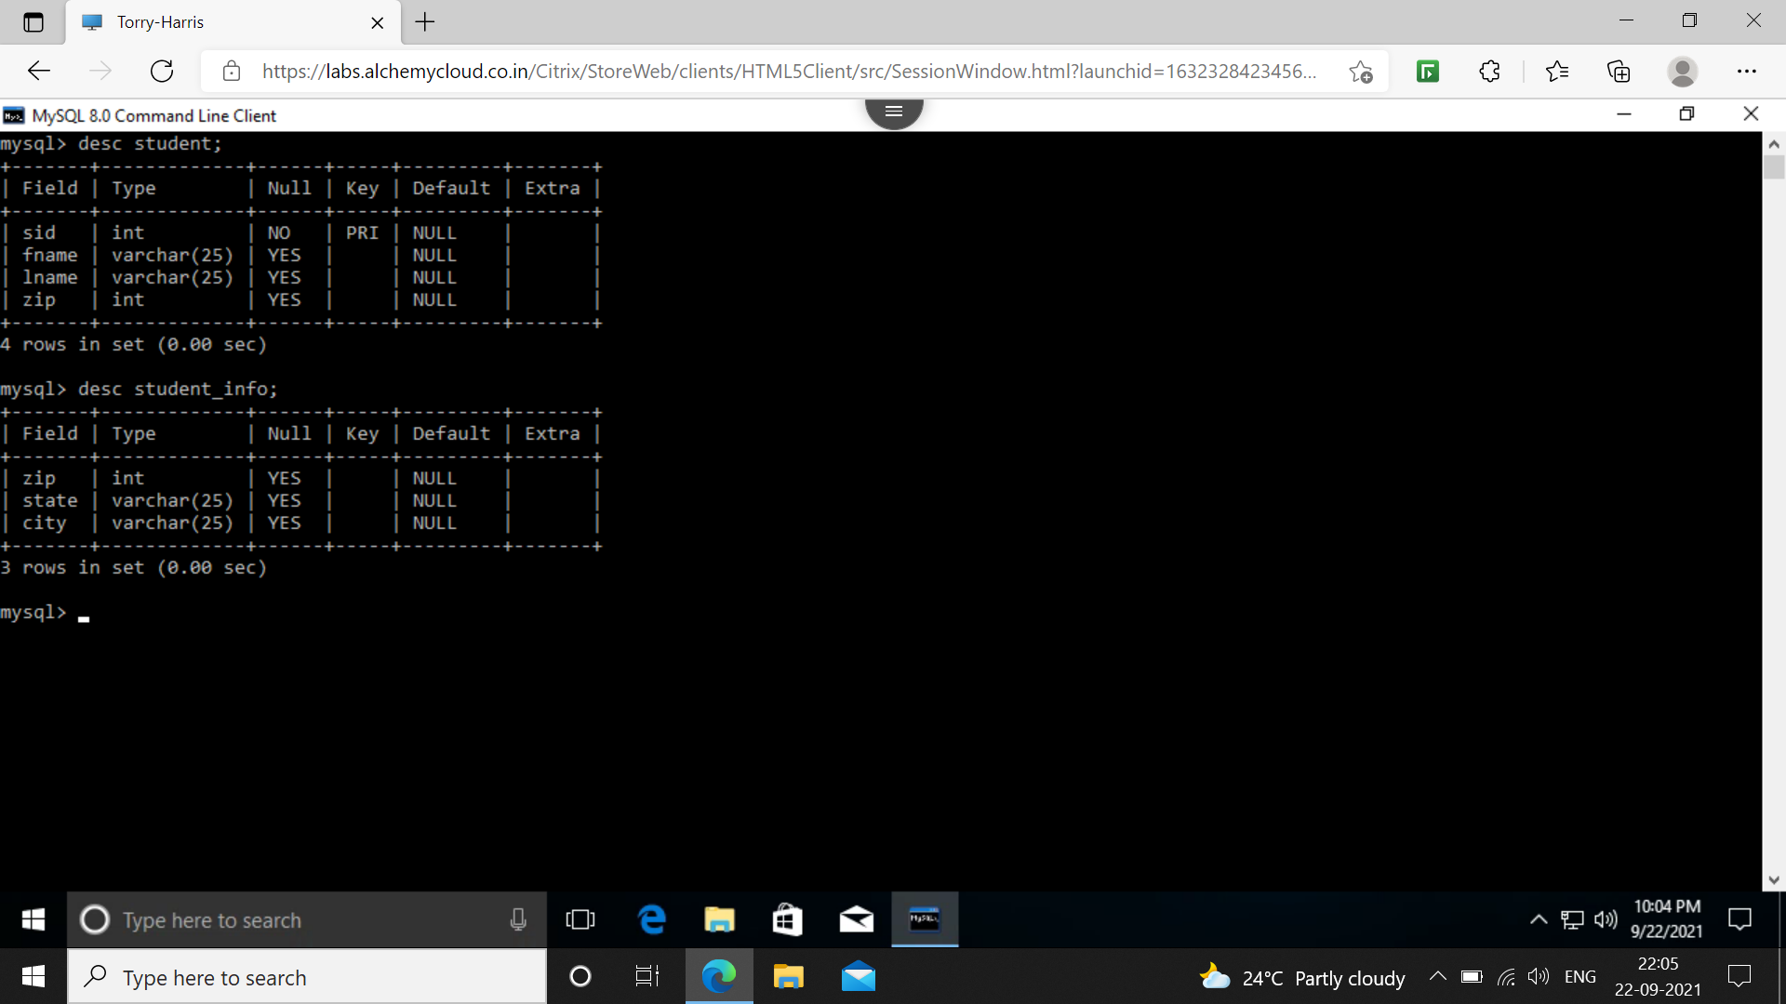

Subqueries: This is nested query or it can also be interpreted as query under a query.

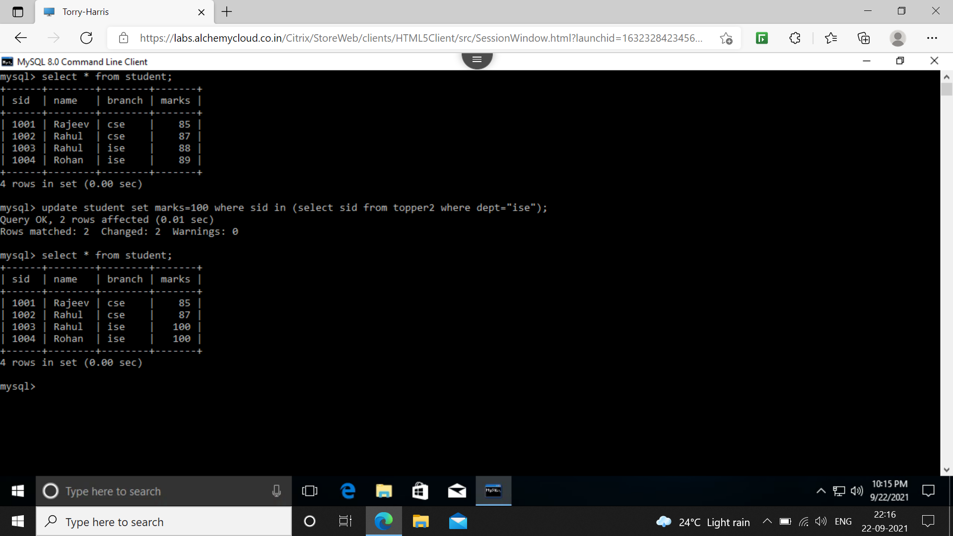

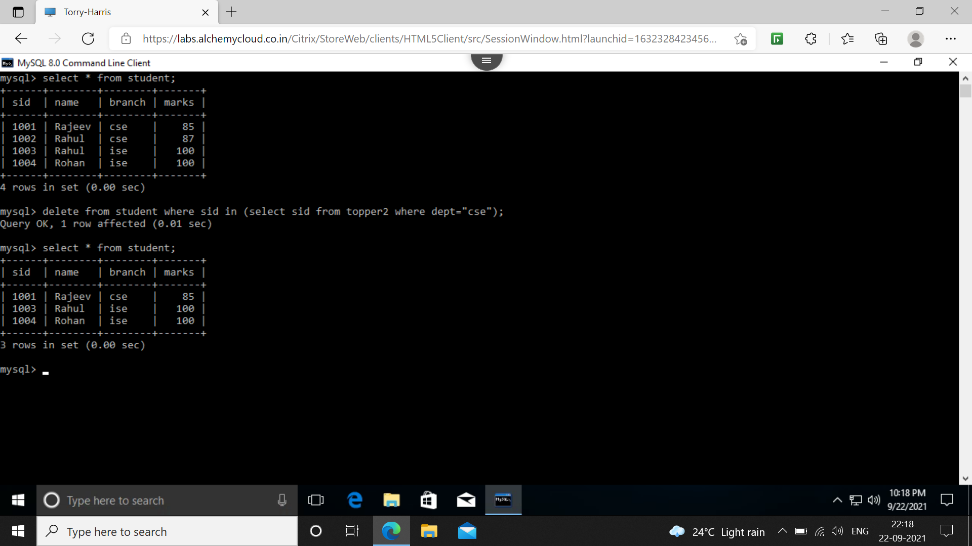

Group by: This command is use to group same or similar rows into single row.

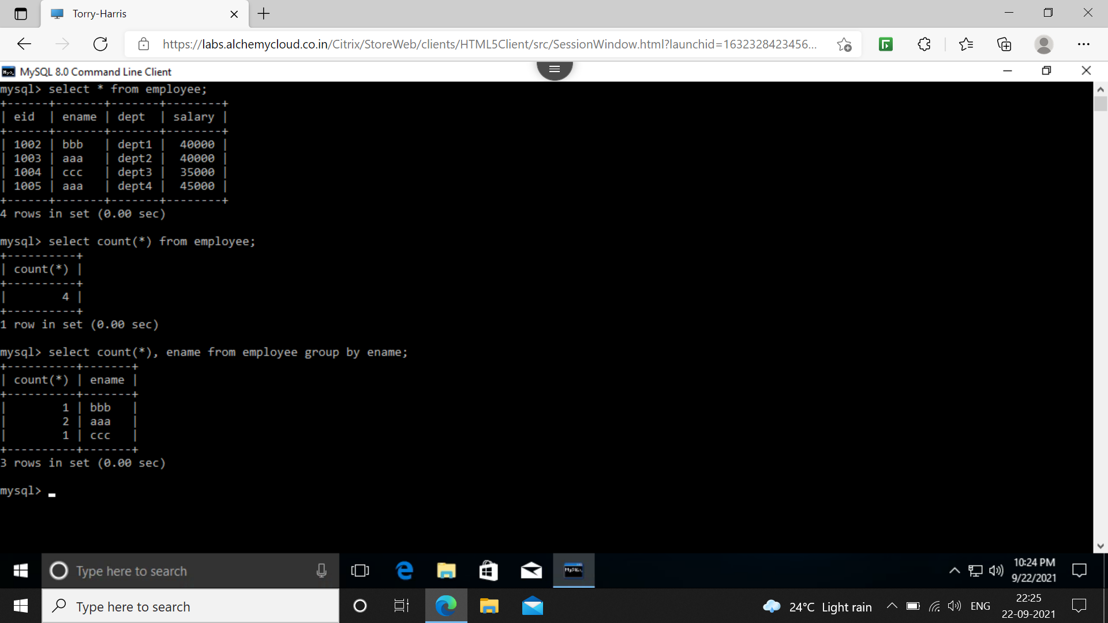

Order by: This command is use to sort contents in ascending order by default and if user want to arrange in descending order then user can use desc at the end of the command.

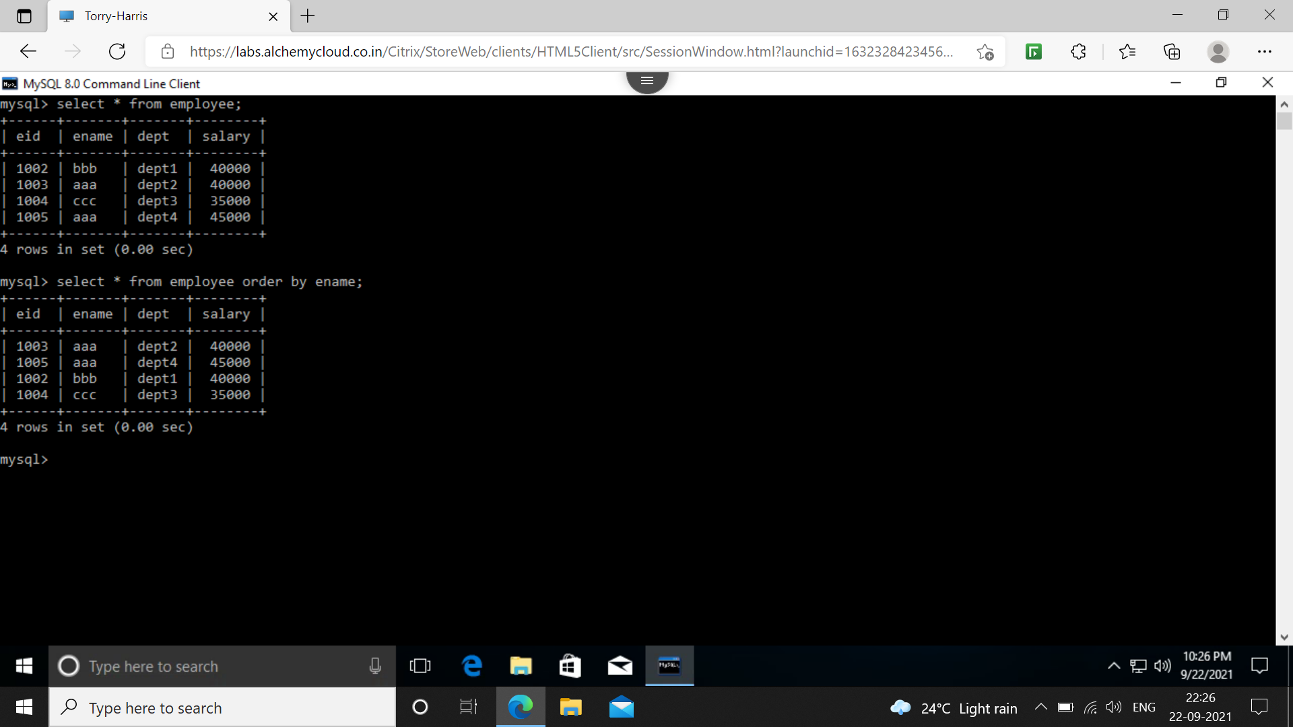

Aggregate functions:
1. sum(): Returns sum of all the values.
2. avg(): Returns average of all the values.
3. min(): Returns minimum value among the other values.
4. max(): Returns maximum value among other values.
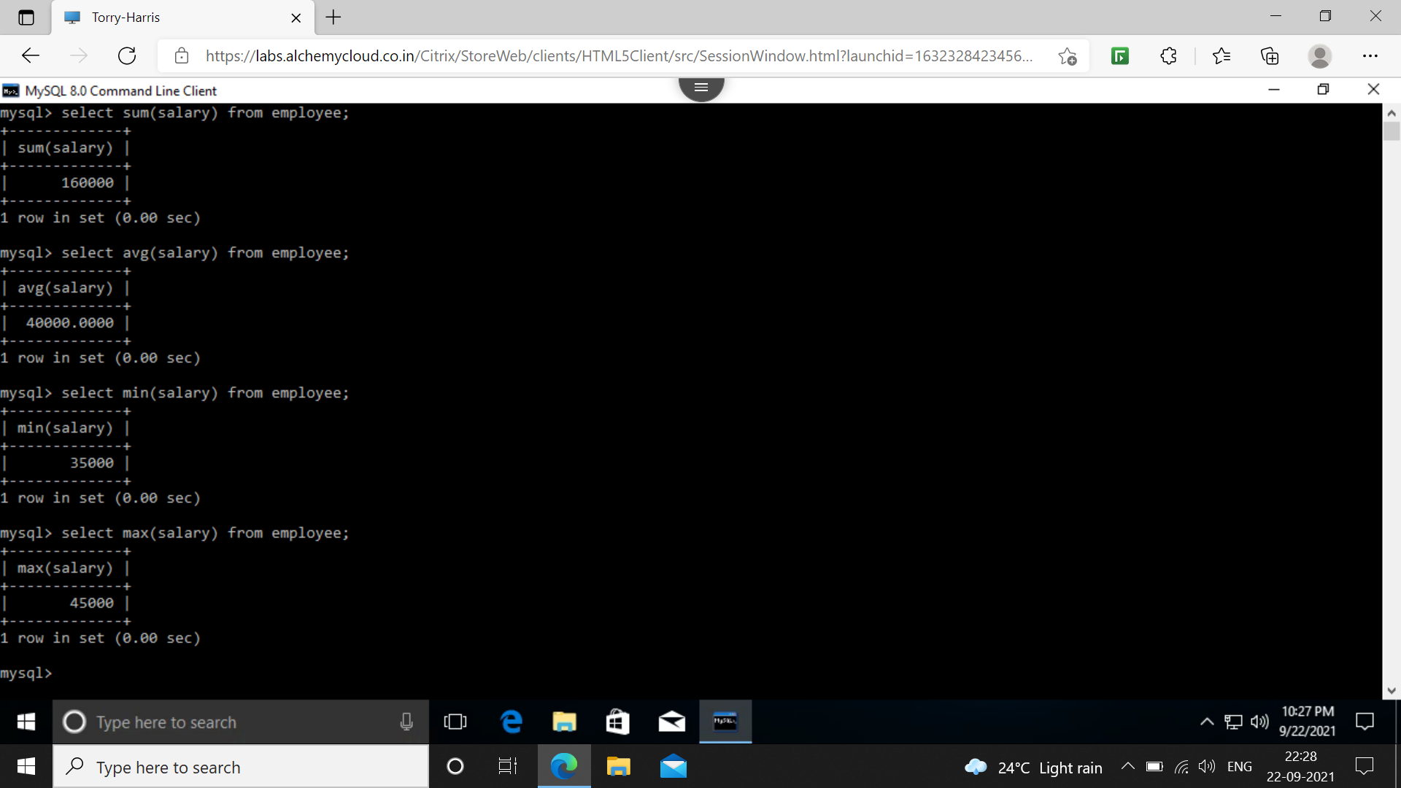

Having: Having is used as an alternative of where, wherever aggregate function is taken into conditions.
